Czech-Austrian Winter and Summer School
Energy efficient houses –
how to promote energy efficient houses?

Lenka Cervena and Therese Schwarz

Co-operating Universities

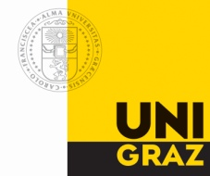

Financial support by

Prague and Vienna, 2010
CONTENT
1. Abstract 3
2. Introduction 4
3. Green Housing in Austria 6
Actual state of green housing in Austria 6
Promotion of energy efficient housing in Austria 7
The research and development program “Haus der Zukunft” 8
The energy identification card – “Energieausweis” 9
4. Sustainable housing in the Czech Republic 10
Actual state 10
Factors influencing passive houses sector in the Czech Republic 10
Information 10
Construction costs 11
Certification 11
5. Promotion of passive houses in The Czech Republic 15
National support program „The Green Savings“ 15
Renovations of old buildings 16
6. Conclusion 17
7. References 19

Abstract

„We simply must balance our demand for energy with our rapidly shrinking resources. By acting now we can control our future instead of letting the future control us.“
Jimmy Carter

In terms of serious discussion about climate change and energy resources people have to think now about technologies and a fundamental change in energy consumption. Due to the exhaustibility of non renewable resources and the increase of energy demand new forms of energy are getting more and more important, however for a long term sustainable development we have to change technology to be more efficient.

More and more the housing sector promotes renewable energy technologies but they are in future not enough to balance our energy consumption. There are different forms of housing that limit the energy demand or even reverse it to energy production.
Low energy houses, passive houses or the energy producing plus-energy houses are new technologies available for the average population.

This paper wants to identify the problems to implement these efficient technologies. The aim of research is to present the status quo in Czech Republic and Austria, furthermore discuss future incentives on the field of eco-friendly housing on European level and highlight the challenges.

Introduction

The European Union wants to achieve their 20-20-20 targets by forcing the implementation of new technologies and wider extent of renewable resources. „Buildings are responsible for 40% of energy consumption and 36% of EU CO2 emissions.“ Therefore sustainable standards for new buildings has to be set and for older ones there are incentives to bring forward renovation.
Three types of energy efficient houses, the low energy house, the passive house and the plus energy house are defined, but there are much more technologies. Low energy houses are described as buildings that have a lower energy demand than the common standard for housing. This term surrounds though other concepts like the passive house, the zero-energy house, the plus-energy house and the 3-liter house.
According to the Passive House Institute, passive houses realize a reduction of energy consumption by 90 percent. Characteristics of the passive house are the following:
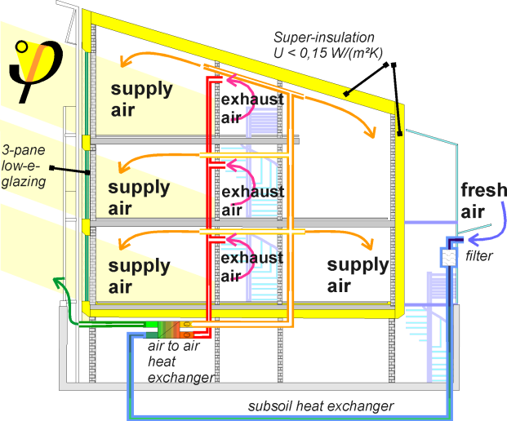
Fig. 1 Passive House Concept
Source: http://www.passivhaustagung.de/Kran/Passive_House_DA_section.png

In winter and summer the house can without much heating effort ensure a convienient temperature. The general heating demand is lower than 15 kWh/(m²a). Including warm water and electicity (multiplied with a factor of 2.8) for all hardware needed in the house the primary energy demand stays by 120 kWh/(m²a). In comparision to the convential buildings passive houses need only 1,5 l heating oil per m2/a. This data can only be achieved through on the one hand good insulation, new windows, an innovative ventilation system and on the other due to a thermal bridge free construction which underlines the environmental conditions of the area.
Compact form and good insulation: | All components of the exterior shell of the house are insulated to achieve a U-factor that does not exceed 0.15 W/(m²K) (0.026 Btu/h/ft²/°F).
Southern orientation and shade considerations: | Passive use of solar energy is a significant factor in passive house design.
Energy-efficient window glazing and frames: | Windows (glazing and frames, combined) should have U-factors not exceeding 0.80 W/(make) (0.14 Btu/h/ft²/°F), with solar heat-gain coefficients around 50%.
Building envelope air-tightness: | Air leakage through unsealed joints must be less than 0.6 times the house volume per hour.
Passive preheating of fresh air: | Fresh air may be brought into the house through underground ducts that exchange heat with the soil. This preheats fresh air to a temperature above 5°C (41°F), even on cold winter days.
Highly efficient heat recovery from exhaust air using an air-to-air heat exchanger: | Most of the perceptible heat in the exhaust air is transferred to the incoming fresh air (heat recovery rate over 80%).
Hot water supply using regenerative energy sources: | Solar collectors or heat pumps provide energy for hot water.
Energy-saving household appliances: | Low energy refrigerators, stoves, freezers, lamps, washers, dryers, etc. are indispensable in a passive house.
Fig. 2 Criteria for passive houses
Source: Passivhouse Institute, 2005, www.passiv.de

The plus energy house is going a step further. The concept is based on that of the passiv house, but moreover the house produces more energy over the year as it needs. The energy demand is covered by solar energy but the electric network is used as a seasonal storage.

Green Housing in Austria

Actual state of green housing in Austria
Climate change and energy crisis force national and international politicians and the population to act in a more eco-friendly and efficient way. Nowadays Sustainablity is a key word for this developments. The Austrian net energy is for the most part out of non renewables, oil and gas and to some extent also from renewable biomass. Concerning the housing sector 330.831TJ in 2005 were needed. However 248.123TJ are useful energy, the rest are losses. The figure shows that there is much potential in reducing energy demand in the field of housing.

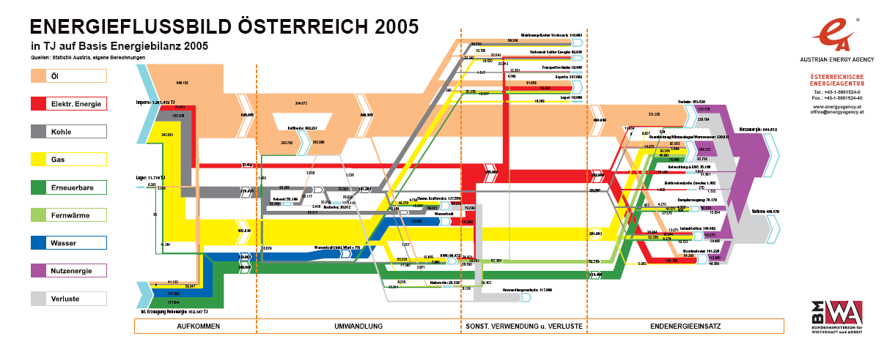
Fig. 3 Austrian energy flow diagram
Source: http://www.econ.jku.at/members/Aiginger/files/teaching/firmen%20und%20maerkte/Oesterreichische%20Energiestrategie.pdf

The Austrian Energy strategy focuses on the reduction of greenhouse gas emissions, increase of renewable energies and last but not least energy efficiency. One of the main solutions to achieve these goals are promoting efforts to energy efficient housing. The avarage Austrian household spends 22,3% of total costs for housing and energy, this is definity the highest amout monthly. Passive or other energy efficient houses have higher initial costs (plus 10%) but lower long term running costs. In the whole product life cycle this provides saving of 100.000€.

In recent years „green“ houses in Austria significantly increased. In 2006 there were 1660 passive houses in Austria. In additional the number of documented projects counts 498 houses. According to the Passive House Institute Austria is the second strongenst country implementing the passive house technology.

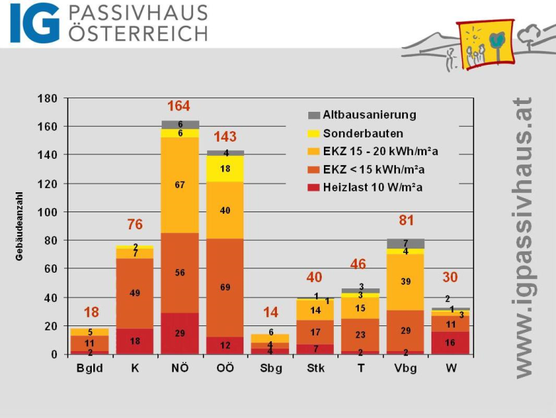
Fig. 4 Different types of passive houses in the federal states of Austria
Source: http://igpassivhaus.cuisine.at/presse/files/20/objekte%20je%20bundesland%202008.jpg

In fact, in Lower Austria there is the highest quantity, while Salzburg and Burgenland have the lowest ones. Relativly seen Vorarlberg has the highest number. Besides there is an increasing renovation of older buildings and public buildings.

Promotion of energy efficient housing in Austria
In Austria there are many activities to promote energy efficient housing: Laws, special programs, information channels and financial incentives. In the following there are a few of them highlighted.
On the European level, due to the introduction of the Building Directive 2002/91/EG national laws were changed and new regulations established. The OBI – Directive, which regulates reduction of energy and heat insulations, controls standards of components, quality of the building’s covering, heating demand, final and total energy demand and last but not least green house gas emissions. The Directive gives details to requirements like thermal bridges, air and wind tightness, energy identification card and all characteristics of the main buildings based on.
According to the energy strategy for Austria the energy efficiency will be increased partly through energy efficient housing. There is an Austrian subsidy for thermal renovation. On the one hand 50 Million Euros were provided by the government for projects on the private household level, on the other hand another 50 Million was spent for business buildings.

The European Energy strategy wants to achieve an increase of energy efficiency by 20%. Therefore the European law, especially the European Directive 2002/91/EG, was implemented by the Styrian law through Article 3 of regulations (LGBl., piece 7, number 13) on March 2nd 2010. It modified the efficiency standards and the method of calculation energy efficiency for buildings.
Concerning subsidies in Styria there are two different types of subsidies small and comprehensive renovation. These requirements applicants have to fulfill: The building permission was accepted for more than 30 years except: Subsidies for district heating, building operations with energy or environmental impact, barrier-free operations, security or new building of residential units.
The limitation of the subsidy is a payment of 30.000€ per flat, additionally if well rated with Eco-Points the sum can increase to 50.000€ per flat.
The comprehensive renovation consists of more than three operations at the exterior walls (e.g. insulation) or other energy saving components (e.g. windows) or technologies (e.g. heating system). The small renovation is characterized by minimal improvements like insulation at thermal bridges.
Minimum requirements are present building standards, solar water heating, non fossil fuels, no materials that harm the nature, a thermo-graphic- and an air-tightness-control. Due to the Kyoto Protocol and other emission-reduction agreements there is a special subsidy program for eco-friendly buildings. Important parameters are the type of building and the utility area. Additional financing is given for special eco-friendly investments or measures.

The research and development program “Haus der Zukunft”
The initiative named “Haus der Zukunft” is founded from the Austrian ministry for traffic, innovation and technology to promote “green” housing. Targets are academic investigations to provide data for a promotion of building for the future, especially plus-energy houses. In particular information about demonstration projects, for instance family houses, apartment buildings, commercial and public buildings such as schools. Innovative technology and products should be developed to accomplish mass production and a wide spread over all over Austria.
Most notably this program combines many promotors of different areas to improve the networking and positive know-how effects. Until 2009 there were several requests for proposals, 700 projects submitted and 300 of them got a subvention. Altogether the Austrian Ministry granted more than 35 million € for this project.

The energy identification card – “Energieausweis”

In general, the energy identification card gives a standardization of the condition of the building. Parameters like the heating energy consumption are listed and give in the end a categorization of the house. Only qualified technicians can issue a certificate. As average price one € per m² can be calculated, but for old or small houses it often increased.
Energy identification cards are required for all new buildings; in this case the setting is within the construction phase. Furthermore all buildings after renovation, rebuilding and/or purchase are obligated. The owner of the building is responsible that this certificate is available. The validity period lasts ten years.

Category | Heating energy demand | Oil equivalent
A++ | ≤ 10 | 200-300 | Passive house
A+ | ≤ 15 | 400-700 | Minimum energy house
A | ≤ 25 | 400-700 | Minimum energy house
B | ≤ 50 | 1000-1500 | Low energy house
C | ≤ 100 | 1500-2500 | Legal requirement
D | ≤ 150 | ˃ 2500 | Old unrenovated buildings
E | ≤ 200 | ˃ 2500 | Old unrenovated buildings
F | ≤ 250 | ˃ 2500 | Old unrenovated buildings
G | ≤ 300 | ˃ 2500 | Old unrenovated buildings

Fig. 5 Energy identification card – categories and measurements
(Designed by the author with information of the ÖNORM H 5055, 2009)

Sustainable housing in the Czech Republic

Actual state
In the Czech republic energy efficient housing sector isn´t as much developed as for example in Austria, Germany or Switzerland that are known as countries with the most green houses built in Europe. In fact the whole process of bringing passive houses in common life in Czech Republic is still at the beginning.
Specialists from The Centre of passive house and many others expect very fast development in the area of building houses in passive standard in the following few years. The boom would be a logical consequence of increasing demand for innovative buildings. The main group interested in modern housing represents young people or families with university degree which have already a bit of knowledge about these technologies from German speaking countries.
Currently there are not more than 100 of passive houses in Czech Republic and some more of low- energy houses. During few previous years many Czech organizations concerning green housing have arisen. To name the most important, these are Passive House Centre or Centre Veronica Hostětín.

Factors influencing passive houses sector in the Czech Republic

Information

Energy efficient housing is still a new challenge for all subjects in house-building industry in the Czech Republic. However, there is not an optimal level of information and knowledge. New companies and consultancy agencies specialized in green building sector are founded. People find different ways of taking over technical know- how of constructing passive houses.
The problem is not in the education system, present students of civil engineering and architecture have already a good knowledge about sustainable houses. Difficulties appear by some existing companies that still have only little experience in this field. This is a very important fact because to make the house in passive standard, the building method must be proceed with highly attention and no changes. Only a small fault would cause big functional defects in the future by inhabitation the house.
We can also see an increase of consumer demand for these houses as well as the awareness about sustainable living of Czech people grows.

Construction costs
A considerable argument against passive housing is its construction costs which are on average about 15 % higher than by conventional houses. On the other hand there are lower costs for heating, so the expected period of investment return is about 12 – 15 years. To help promote new technologies that reduce energy demand and save natural resources Czech government introduced a special supporting program The Green Savings, described later in the paper.
The concept of sustainable housing is promising not only because of the environmental reason, but of the economical reasons too. Prices of energy in the Czech Republic rise every year (see Picture 1: Prices of energy in CR) and therefore energy savings mean costs savings.
Picture 1: Prices of energy in CR
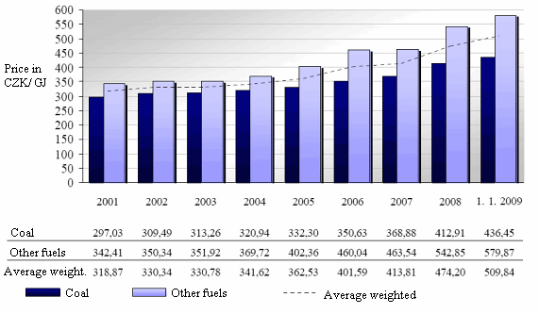
Source: Technická zařízení budov

Certification

Certificates have very important role in sustainable building area. First they represent a certainty that the building meet more or less strict requirements concerning nature protection and energy efficiency, second they are a good marketing tool for all civil engineering companies or for the specific building itself.
Worldwide several certification system exist that are focused on sustainable buildings, including environmental, social and economical aspects such as energy efficiency, water efficiency, low CO₂ emissions houses, pleasant environment etc. The mostly used certificates in Europe are DGNB (Deutsche Gesellschaft für Nachhaltiges Bauen, GE), LEED (Leadership in Energy and Environmental Design, US), BREEAM (BRE Environmental Assessment Method, GB) or GreenBuilding (EU). All these certificates were designed likely for commercial or administrative complexes.
Concerning reducing energy consumption and CO₂ emissions among EU members, Energy Performance of Buildings Directive (2002/91/ES) was adopted in 2002 by European Commission. The aim of this directive is to apply minimum requirements as regards the energy performance of new and existing buildings, to ensure the certification of energy performance and require the regular inspection of boilers and air conditioning systems in buildings. The directive has also introduced among others a new instrument of energy policy, Energy performance certificate.
In the Czech Republic the Energy performance certificate was launched on January 1, 2009. Currently the certificate is obligatory used for every new building and building that has been reconstructed in way influencing its energy performance and for buildings of living area larger than 1.000 m². Reconstruction influencing energy performance means according to rule reconstructions of more than 25 % of building skin or a change of heating system.
The certificate measures the energy demand and effectiveness of the building. The building is labeled with a letter from A to G. Letter A signify a house with lowest energy intensity, letter G the highest. The aim is to develop a pressure on energy efficiency. Examinated are not only heating, but also energy for water heating, for ventilation, cooling, lightening, pumps etc. Not included are electric appliances such as refrigerator, washer, washing machine or computers.
Administration of energy performance certificate area is in hands of Ministry of Industry and Trade of the Czech Republic. Certificates are allowed to issue only authorized persons, their list can be found on Ministry websites.

Picture 2: Energy performance certificate
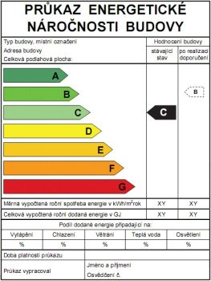
Source: EkoWATT

To ensure required quality level of common family or apartment houses in passive or low-energy standard, specific guidelines have to be kept. In the Czech Republic it means to follow standards TNI 73 0329:2009 (family houses) and TNI 73 0330:2009 (block of flats). The calculation depends on climate conditions (temperature, amount of solar radiation) that differ in each part of the country. So the classification of buildings is the same for all places in the Czech Republic.

Picture 3: Climate conditions in CR
Month | Days | Air Tempe-  rature | Energy of solar radiation [kWh/m²]
 |  | °C | North | South | East | West | Horizont | North-east | North-west | South-east | South-west
January | 31 | -0,1 | 7 | 50 | 15 | 20 | 23 | 12 | 12 | 37 | 44
February | 28 | 1,0 | 13 | 55 | 26 | 28 | 40 | 20 | 20 | 47 | 51
March | 31 | 4,0 | 23 | 82 | 51 | 53 | 79 | 36 | 37 | 73 | 76
April | 30 | 9,0 | 32 | 95 | 74 | 72 | 118 | 51 | 49 | 92 | 86
May | 31 | 14,6 | 47 | 97 | 104 | 93 | 161 | 79 | 73 | 109 | 98
June | 30 | 17,0 | 52 | 87 | 115 | 88 | 166 | 91 | 73 | 108 | 88
July | 31 | 18,2 | 47 | 93 | 100 | 93 | 162 | 78 | 75 | 103 | 97
August | 31 | 18,8 | 38 | 100 | 88 | 88 | 143 | 64 | 63 | 101 | 100
September | 30 | 13,8 | 24 | 95 | 60 | 64 | 96 | 38 | 40 | 82 | 86
October | 31 | 9,4 | 17 | 75 | 34 | 48 | 57 | 21 | 25 | 51 | 71
November | 30 | 4,0 | 9 | 36 | 14 | 18 | 24 | 10 | 11 | 25 | 32
December | 31 | -0,5 | 5 | 29 | 11 | 12 | 17 | 9 | 9 | 23 | 26
Source: TNI 73 0329 a TNI 73 0330

Promotion of passive houses in The Czech Republic

National support program „The Green Savings“
In order to fulfill the vision of energy efficient housing the Czech government began to provide financial, administrative and advisory support for several arrangements in the housing sector in April 2009. This program is called The Green Savings (Zelená úsporám) and represents financial support for those installing innovative energy solution into their houses.
It includes savings of energy used for heating, using renewable energy sources for heating and water warming and for building passive houses (see Table 1: The Green savings program). The whole program is financed from money gained by selling “emissions credits” to Japan in terms of The Kyoto protocol that aims to reduce emissions of greenhouse gases.
Table 1: The Green savings program
The Green savings program
- Energy savings from heating
A.1. Total insulation
A.2. Particular insulation
- Passive houses
- Using renewable resources for heating and water warming
C.1. Switch from non-ecological heating to low-emissions biomass sources and pumps
C.2. Installation of low-emissions biomass sources and thermal pumps
C.3. Installation of solar collectors
Source: Ministry of Environment CR
Concerning passive houses subvention, there are possibilities to either build-up a new house or reconstruct existing buildings into passive standards. The support is accessible for both family houses and blocks of flats. Lately the program was extended also for the sector of public buildings. The amount of money provided is shown in Table 2: Support for family houses and .
Table 2: Support for family houses
Arrangement | Financial support
Family house in passive energy standard | 250.000 CZK (ca 9.800 EUR)
Support for the project | 40.000 CZK (ca 1.570 EUR)
Source: Ministry of Environment CR
Table 3: Support for blocks of flats
Arrangement | Financial support
Block of flats in passive energy standard | 150.000 CZK (ca 5.900 EUR)
Support for the project | 40.000 CZK (ca 1.570 EUR)
Source: Ministry of Environment CR
In order to get the subventions houses have to fulfill the criteria of max. 20 kWh/m² (family houses) and 15 kWh/m² (blocks of flats) of space heat demand per year. The project has to be finalized between April 2009 and December 2012, it´s not possible to finance projects made before April 2009.
In order to get the support the project has to be made by authorized architect or has to comprise a product or technology scheduled in a special list. It´s recommended to discuss the possibility to get support with a specialist. Then the applicant has to fill the application form and deliver it together with the project to The State Environmental Fund office or a bank. In 10 weeks he becomes a notifications about (not) getting the support. The support is not provided before the project is finished.
The Green Savings program ends in December 2012. It´s considered that the final amount of provided financial support between the years 2009 and 2012 is going to be 25 billion CZK. The project was accepted very well by the public and about 19.000 applications were received by The State Environmental Fund of the Czech Republic so far. There were many applicants for passive house support (out of the whole program), but the number of applications administered in comparison to other arrangement is still small as they need more investment and time to prepare the project.

Renovations of old buildings
Very important fact is that The Green Savings program is designed not only for construction of new buildings but also for renovating old buildings into passive standards. In renovations of already existing buildings we can expect the most of energy savings because these buildings compose the biggest share of housing sector.
Regarding environmental burden it´s usually better to do sanitations in an old building (that is in a good condition) than to demolish it and rebuilt a new one. Behaving this way we avoid unnecessary waste from demolition works, reuse the materials and keep the historical value of the building.

Conclusion
According to a study made by Stieß et al. in Germany, there are some factors, which determine the open-mindedness towards energy efficient renovation of house owners. They announced that the technical and economical potential is not exhausted. First and foremost owners are thinking about the investment costs but it was verified that in this stadium a very individual personal option about energy efficiency play a big role in the purchase decision. Social and demographic situation, life style and relationship to the building are a few very important drivers. Most of the survey participants who made an energy efficient renovation had a higher educational standard and a high or middle class income. Concerning age, most of the renovators with energy interests are between 50 and 70 years. The paper highlights clearly that the strongest motivations to renovate are personal goals, the relationship to the building and the life style of the owner.

The efficient housing is technically well developed but there is sufficient potential for climate change and energy savings in Austria. In the last years the topic was well promoted but there is a lack of information about subsidies, common errors and the newest standards. Most of new build passive or plus houses are in scientific programs. Especially concerning passive houses Austria demonstrate a yearly growth rate of 100%.
Due to the Austrian housing subsidy program the applicant have to manage to get the subsidy a package of standards. 50% of all new buildings should have therefore the “klima:aktiv” standards. As of 2015 only “klima.aktiv” standardized large volume houses will get the subsidy anymore.
Clearly, Austria is improving the building standards not only through financial incentives but also through legal regulations and strategic and scientific projects.

Concerning the Czech Republic, numbers of successful energy-efficient houses projects and experience from abroad prove that this concept has a great (so far regrettably not entirely utilized) potential. Although there is in comparison with Austria only a fraction of these houses built, significant development is expected by specialist.
Problems appear by common people that are maybe not enough informed about the advantages of passive and low-energy houses or are still a little bit skeptical about these technologies. To avoid this it´s highly important that companies running green housing business have qualified specialist with sufficient knowledge and experience, because few bad experiences can discourage people from building these houses.
To promote energy-efficient houses is a deal not only for companies but also for Czech government that has commited to EU to support energy efficiency and renewable sources of energy. For this reason special program (The Green Savings Program) is runned by Czech Ministry of Environment that provides financial grants for building passive houses or for renovations into passive standard.
In May 2010 The Directive on energy performance of buildings (2002/91/EC) was revised that means strengthening of energy performance requirements and streamlining some of its provisions. Consequently this strengthening can contribute to better promotion of efficient buildings. Besides this there are also some suggestions in field of green housing policy for the future. One of the proposals is to build all new public buildings in passive standard. On the one hand governments should provide financial incentives and information campaigns on the other hand their own buildings like schools and public institutions should be best practice examples. However, building all public buildings in passive standard seems to be at present rather unrealistic although major part of specialists agree that energy-efficient housing is the housing of the future.

References

In German:
http://ec.europa.eu (European Commision)
http://www.lowenergyhouse.com/
http://www.passiv.de
www.plusenergiehaus.de
www.econ.jku.at (Energy strategy Austria)
www.energiesparen-im-haushalt.de (Costs for pasive houses)
http://igpassivhaus.cuisine.at
http://www.verwaltung.steiermark.at/
www.hausderzukunft.at (Program „Haus der Zukunft“)
www.energieausweis.at (Energy identification card)
Stieß, Immanuel et al.: Handlungsmotive, -hemnisse und Zielgruppen für eine energetische Gebäudesanierung, 2010, Frankfurt : http://www.enef-haus.de/fileadmin/ENEFH/redaktion/PDF/Befragung_EnefHaus.pdf
WKO Austria - Energiesparendes Bauen von Baumeister: http://portal.wko.at/wk/startseite_dst.wk?dstid=131
http://www.oib.or.at/EB6_250407.pdf (OIB, 2007)

http://eur-lex.europa.eu/LexUriServ/LexUriServ.do?uri=OJ:L:2003:001:0065:0071:DE:PDF (EU-Directive 2002/91/EG)

http://www.ris.bka.gv.at/Dokumente/Lgbl/LGBL_ST_20100302_13/LGBL_ST_20100302_13.pdf (federal law Styria 2010)

http://www.verwaltung.steiermark.at/cms/beitrag/10005305/276011/ (Styrian subsidy)

http://www.verwaltung.steiermark.at/cms/dokumente/10005006/7d4f5b16/oekori.pdf (Styrian eco friendly building subsidy)

In Czech:
Hudcová Lenka and team: Energetická náročnost budov, EkoWATT
on-line available on http://ekowatt.cz/library/dokumenty/Energeticka_narocnost_budov.pdf
Ekologický institut Veronica: Pasivní dům II – zkušenosti z Rakouska a české začátky, Brno 2008, online on http://www.veronica.cz/dokumenty/pasivni_dum_2008.pdf
www.casopisstavebnictvi.cz
www.bydleni.idnes.cz

http://stavba.tzb-info.cz

www.ekolist.cz

www.ekowatt.cz

http://www.zelenausporam.cz/ (The Green Savings Program)

http://www.mzp.cz (Czech Ministry of Environment)

Carter, Jimmy: http://www.betterworld.net/quotes/energy-quotes.htm (10.5.2010)
European Commission: Energy; http://ec.europa.eu/energy/efficiency/buildings/buildings_en.htm (10.5.2010)
Low Energy house: http://www.lowenergyhouse.com/ (12.5.2010)
Passiv house: http://www.passiv.de/index_14PHT.html (12.5.2010)
Plus energy house: http://www.plusenergiehaus.de/index.php?p=home&pid=8&L=0&host=1#a1 (12.5.2010)
Energy Strategy Austria: http://www.econ.jku.at/members/Aiginger/files/teaching/firmen%20und%20maerkte/Oesterreichische%20Energiestrategie.pdf
http://www.google.de/imgres?imgurl=http://www.wko.at/statistik/wgraf/wk2006_07haushaltsausgaben.jpg&imgrefurl=http://www.wko.at/statistik/wgraf/wk2006_07haushaltsausgaben.htm&usg=__X_lJl4E-Nscfw8d2mkUAQ3aC6LI=&h=645&w=626&sz=85&hl=de&start=19&itbs=1&tbnid=VcpkkXwjTI4A9M:&tbnh=137&tbnw=133&prev=/images%3Fq%3DEnergie%2Bf%25C3%25BCr%2BWohnen%2BStatistik%26start%3D18%26hl%3Dde%26sa%3DN%26ndsp%3D18%26tbs%3Disch:1
Costs for passiv houses: http://www.energiesparen-im-haushalt.de/energie/bauen-und-modernisieren/hausbau-regenerative-energie/passivhaus-bauen/passivhaus-kosten.html
Data about passiv houses: http://igpassivhaus.cuisine.at/presse/ergebnisse_neu.php?start=0&byevent=20
OIB: http://www.oib.or.at/EB6_250407.pdf
EU-Directive 2002/91/EG: http://eur-lex.europa.eu/LexUriServ/LexUriServ.do?uri=OJ:L:2003:001:0065:0071:DE:PDF
Gesetzesblatt Styria 2.3.2010: http://www.ris.bka.gv.at/Dokumente/Lgbl/LGBL_ST_20100302_13/LGBL_ST_20100302_13.pdf
Federal state of Styria: http://www.verwaltung.steiermark.at/cms/beitrag/10005305/276011/
Subsidy: http://www.verwaltung.steiermark.at/cms/dokumente/10005006/7d4f5b16/oekori.pdf
Program „Haus der Zukunft“: http://www.hausderzukunft.at/projekte/suchergebnis.html?showparam=1&showmod=0&showtech=058&zeitraum=1900-01-01&langid=0&techid=8&bereichid=2,7&beranzeige=iprojekt,publ&ref=/projekte/index.htm&keywordid=506
Energy identification card: http://www.energieausweis.at/energieausweis-aussteller-liste.htm
http://www.casopisstavebnictvi.cz/trh-s-pasivnimi-domy-akceleruje_N3049 (11. 4. 2010)
http://bydleni.idnes.cz/nizkoenergeticke-versus-pasivni-domy-dxx-/architektura.asp?c=A081107_150306_architektura_web (12. 4.. 2010)
http://bydleni.idnes.cz/nizkoenergeticke-versus-pasivni-domy-dxx-/architektura.asp?c=A081107_150306_architektura_web (12. 4.. 2010)
http://stavba.tzb-info.cz/t.py?t=2&i=6323 (16.4. 2010)
http://www.ekolist.cz/zprava.shtml?x=2220112 (14.4. 2010)
The directive was revised on May 18, 2010 so that the energy performance requirements are strengthened. The document is going to be published in June 2010.
http://europa.eu/legislation_summaries/energy/energy_efficiency/l27042_en.htm (9.6. 2010)
http://www.ekowatt.cz/cz/informace/uspory-energie/prukaz-energeticke-narocnosti-budovy (9.6. 2010)
http://www.ekowatt.cz/cz/informace/uspory-energie/prukaz-energeticke-narocnosti-budovy (23. 4. 2010)
http://www.mpo-enex.cz/experti/ (9.6. 2010)
Hudcová Lenka a kol.: Energetická náročnost budov, p. 33, online available at http://ekowatt.cz/library/dokumenty/Energeticka_narocnost_budov.pdf (23.4.2010)
http://www.zelenausporam.cz/sekce/501/na-co-je-mozne-zadat/ (14. 3. 2010)
The list is avaiable on-line here: http://www.zelenausporam.cz/vyhledavani/sod/ (4. 5. 2010)
The list is avaiable on-line here: http://www.zelenausporam.cz/vyhledavani/svt/ (4. 5. 2010)
http://www.zelenausporam.cz/sekce/504/jak-je-mozne-zadat/ (4. 5. 2010)
http://www.mzp.cz/cz/articles_ekolist090407zelena_usporam (14. 3. 2010)
http://www.zelenausporam.cz/clanek/551/1082/zajem-lidi-o-program-zelena-usporam-stale-roste/ (5. 5. 2010)
http://www.asb-portal.cz/tzb/energie/energeticky-efektivni-sanace-budov-1209.html (10.6.2010)
Stieß, Immanuel et al.: Handlungsmotive, -hemnisse und Zielgruppen für eine energetische Gebäudesanierung, 2010, Frankfurt, http://www.enef-haus.de/fileadmin/ENEFH/redaktion/PDF/Befragung_EnefHaus.pdf
WKO Austria- Energiesparendes Bauen von Baumeister: http://portal.wko.at/wk/startseite_dst.wk?dstid=131

